PRESS RELEASE FOR PUBLICATION

Leonberg, 27 June 2016

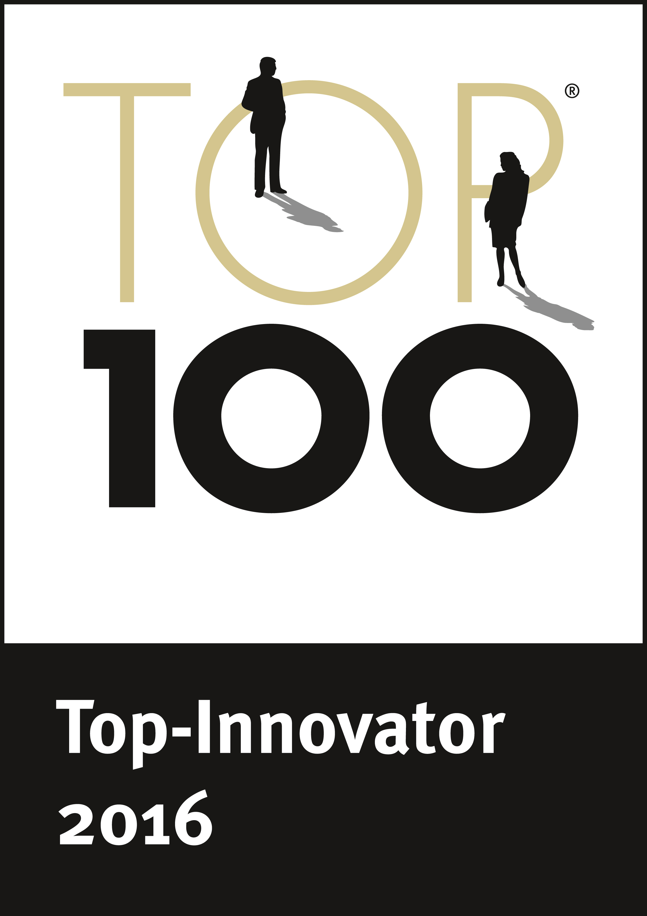
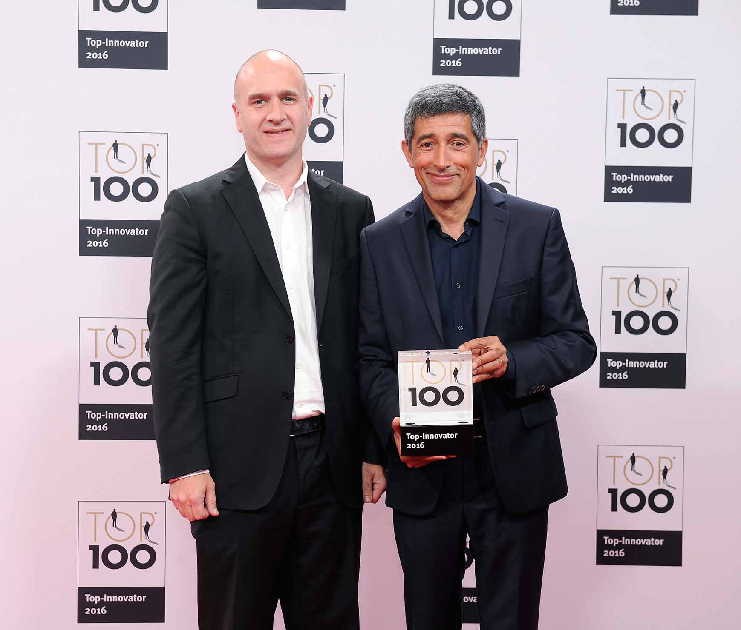

Photo: GEZE GmbH
Gala event to honour the companies which are the Top 100 Innovators of 2016:
The science journalist Ranga Yogeshwar hands the
Top 100 Innovator certificate to Florian Birkenmayer, Managing Director Development

7th Top Innovator award

GEZE is one of the most innovative companies in Germany
Top 100 award for outstanding innovation management

GEZE has received the prestigious Top 100 award for the seventh time and can therefore be considered one of the most successful innovators in Germany. The decisive competitive factors when comparing the different companies were 'innovation climate', 'innovative processes and organisation', 'top management encouraging innovation' and 'innovation marketing'. At the Gala evening of the 3rd German SME summit held in the Colosseum Theater in Essen, GEZE received the award from Ranga Yogeshwar, Top 100 mentor and science journalist. The evening was hosted by newsreader Judith Rakers.

GEZE is a long-established member of the leading international group of developers and manufacturers of innovative systems in the field of door, window and safety technology. In the last three years alone the company has been awarded 108 patents in Germany and 191 abroad.

"Looking at the widest possible range of options is the GEZE formula for producing innovations and enhancing our products and know-how. We do this by observing trends and developments in architecture, in society, and in technological fields, and by checking how we can make use of them to create innovative, marketable products. For example, network technologies and communications standards for the interoperability of devices in the field of premises and building systems technology provide valuable ideas for enabling us within the next few years to offer systems for controlling the full range of building management systems within the "intelligent" building, says Florian Birkenmayer, Managing Director Development.

The latest innovations are interface modules for integrating GEZE products into the system environment for the intelligent networking of building, so that a building becomes a Smart Building. Automated and networked building functions with solutions from GEZE make buildings more comfortable, increase security in the building, reduce energy consumption and create new visual possibilities.

Optimal R&D conditions for innovation
With the continuous optimisation of its product development processes and its modern tools GEZE provides the ideal conditions for its intensive research and development activities. Over the last two years ideas management has been expanded and is now fully supported by IT. The new product development process (PDP) ensures that employees from any area of the company at any GEZE site in the world can contribute their ideas and suggestions for new products and business models simply, efficiently, and at the earliest possible stage. The new platform optimises networking within the company and ensures that all the important experts and aspects are included from the outset so as to bring innovative products that offer every prospect of success to market as quickly as possible.

Important inputs are provided by the "pre-development" unit which provides a dedicated space away from day-to-day work where GEZE technicians in cooperation with the strategy team and the product-specific developer teams can work on issues and solutions which do not necessarily lead to a marketable product. Once the decision has been taken to transform an idea into a product or system, the marketing experts are brought in. They find out how much added value the new solution provides for the end consumer or installation companies in the national or global markets so that they can be serviced in the most appropriate and targeted way possible.

GEZE is also expanding its development capacity in order to be able to undertake research and development in the best possible way – not just from a methodological perspective – in the ever-growing and increasingly "creative" and complex building management systems market of the future. On 20th June 2016 the ground-breaking ceremony took place for a new development centre with state-of-the-art facilities. The new building complements a production hall which came into operation in the summer of 2015, enabling GEZE to also enhance its manufacturing processes and to cater for customers' requirements in an even more targeted and flexible way in future. The production hall includes a manufacturing facility for producing customised project solutions, many of which are themselves innovations.

Scientific Directorof the and cooperation partner
Since 2002 Prof. Nikolaus Franke of the Institute for Entrepreneurship and Innovation of Vienna University of Economics and Business is Scientific Director of the competition. The main focuses of Franke's research are entrepreneurship, innovation management and marketing. The scientist is one of the leading global experts in the field of user innovation. The project partner of the "Top 100" awards is the Fraunhofer-Gesellschaft (Fraunhofer Society for the advancement of applied research). Further information is available at www.top100.de.

compamedia, mentor of the best medium-sized businesses
The compamedia GmbH was founded in 1993 and organises the national comparisons of companies throughout Germany – the "Top 100“, the "Top Job", and "Top Consultant" competitions – and it has set up the "Ethics in Business" alliance to promote ethical business practice. Through the alliance it supports and rewards medium-sized companies which produce outstanding achievements in the fields of innovation, personnel management, consultancy, and corporate social responsibility. compamedia collaborates with renowned universities on all its projects.

